**Lab 1: SPICE Simulation of Rectifier Circuits (2% of total)**

**Objective:**

To review the use of SPICE1 simulation tool, and to simulate the working of a rectifier circuit.

**Equipment:**

* Multisim (or an equivalent SPICE simulator)

**Pre-Lab:**

Read section 4.5 of the textbook and answer the following questions:

1. What is the purpose of a rectifier?
2. What is the key difference between a Half-wave and Full-wave rectifier output?

**Procedure:**

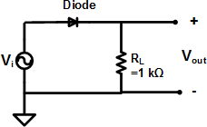 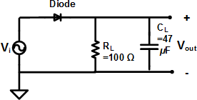

Figure 1.1 Half wave rectifier Fig. 1.2 Peak rectifier

**Part 1:**

1. Build the Half-wave rectifier circuit using a SPICE simulator like LTSpice or Multisim. Note various different diode models can be selected. Choose a basic silicon diode, eg. 1N4148.
2. Provide a sinusoidal input of 10Vpk-pk and 1kHz.
3. Run a transient analysis simulation.
4. *Note:* *Regarding the step size (or time step)* – small step sizes will give you better resolution but the simulation will take a long time to complete, whereas large step sizes will give fast results but at the cost of reduced resolution. The step size should be 1/10th to 1/100th of the total run time.
5. Record the plot for Vin and Vout. Record the peak voltage value for Vout and label it as Vp.

**Part 2:**

1. Consider the Peak rectifier circuit from Fig. 1.2.
2. Use the same input source as Part 1, and simulate the following:
   1. Peak detector I: Use **RL**  = 1 kΩ, **CL** = 47 *μ*F.
   2. Peak Detector II: Use **RL**  = 100 Ω, **CL** = 47 *μ*F
3. For both simulations:
   1. Record the plot for Vin and Vout. Record the peak voltage (Vp) and average of the output voltage (Vavg).
   2. Using the formulas given below, calculate the ripple voltage (VR), and DC voltage (VDC).

Formulas for calculating VR and VDC:

For the Peak detector circuit, use the value of *VP* based on the rectified output (dark curve below) in the calculations. You should also verify that the DC value obtained from Eq. (2) matches the approximate average value of the rectified output. They should be very close.

**......................................................................(1)**

**.......................................................(2)**

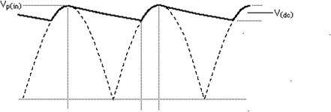

***∆t ∆t =*** time between successive peaks

**Conclusion:**

1. Summarize the measured and calculated results in a tabular form. *Get your summary table checked off by the instructor.*
2. Which among the 3 circuits is the best rectifier?
3. What do you think is happening with the addition of the capacitor?

----------------------------------------------------------------------------------

1SPICE: **S**imulation **P**rogram with **I**ntegrated **C**ircuit **E**mphasis